**Homework Cover Sheet**

**Student Name:**

**SBU ID:**

**Homework # (Unit):**

**Instructions:** In the space below, list *all* resources that were used in the completion of this assignment. This must include any books, websites or other reference materials that were consulted, as well as a list of any people that you discussed the problems with. Please note that all resources that were consulted in trying to answer any of the problems on the assignment must be included, even if you do not feel that the resource helped. *Note, if the only resources you used were the class text(s) and lectures, list those; do not leave this page* blank. **By signing below, I attest that the statements made above represent a complete accounting of the materials I used in completing this assignment. I understand that the failure to disclose the use of any resource is an act of academic dishonesty subject to penalty by the Academic Judiciary.**

**Signature:**

**Date:**

Brian Wang

113355615

Project #1

*I worked together with Xin’er, Aaron, Amrita, Kevin on the Matlab project. We worked on our own code but our individual codes were influenced by the people in group as we gave feedback when we were stuck. I also used the MATLAB documentation and Wikipedia extensively -Brian*

**Part A: Understanding the Hill Equation**

The hill equation is primarily used in biochemistry to graph the rate of reaction for a ligand binding to a receptor dependent on the concentration of the substrate. The hill equation is represented as:

$$v=\frac{V_{max}{\left[S\right]}^{h}}{K_{1/2}^{h}+{\left[S\right]}^{h}}$$

$v$ represents the reaction velocity of the receptor binding. $V_{max}$ is the maximum reaction rate for this system. $\left[S\right]$ is the substrate concentration. $h$ is an abstract esoteric variable called the hill coefficient that modulates how the system reacts to different substrate concentrations. $K_{1/2}$ is the substrate concentration in which the reaction velocity will reach exactly half of its maximum reaction velocity. The following graphs and captions will explain how the effect changing each variable will have on the graph.

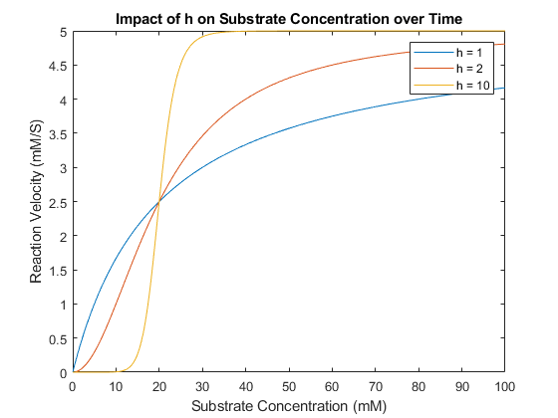

**Part1a** hill equation plots with $\left[S\right]=0$ to $100$. $V_{max}=5.0mM/S$, $K_{\frac{1}{2}}=20.0 mM$, with a variable h value. Since $V_{max}$ is the same for all 3 systems, all of the reaction velocities will max out at $5 mM/S$. Likewise, the $K_{1/2}$ of each system is same so we’ll see the reaction velocities reach it’s halfway mark at $20.0 mM$ for all 3 systems. The different values of $h$ impacted the steepness of the curves, with $h=1$ being the least steep but with a high initial rate of change in velocity and $h=10$ being the steepest with an flat initial reaction velocity.

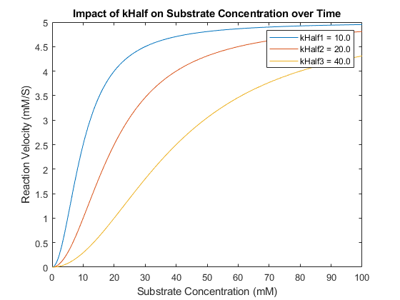

**Part1b** hill equation plots with $\left[S\right]=0$ to $100$. $V_{max}=5.0mM/S$, variable $K_{\frac{1}{2}}$, and $h=2$. All systems will have a ceiling reaction velocity of $5 mM/S$ as dictated by $V_{max}$. The differences in $kHalf$ increases the substrate concentration necessary for the reaction velocity to reach half of the maximum reaction velocity as $kHalf$ increases.

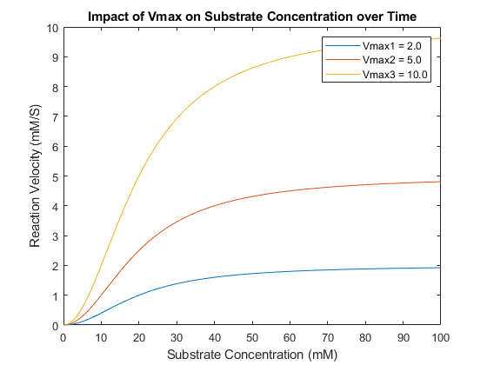

**Part1c** hill equation plots with $\left[S\right]=0$ to $100$. Variable $V_{max}$, variable $K_{\frac{1}{2}}=20 mM$, and $h=2$. One of the most common distinct observations about this system is that the curve flattens based on the value of Vmax; the lower the value, the flatter the curve will be. One thing to note though is that despite the graphs looking dissimilar they all have the same $k_{1/2}$ of $20 mM$.

From the results of the three graphs, we can see how changing each variable will affect the shape of the curve. Changing $h$ will change how the reaction velocity reacts to changes in substrate concentration; a higher $h$ value will create a steeper slope. Changing $k_{1/2}$ will change the substrate concentration required for the system to reach half of its maximum reaction velocity. Changing $V_{max}$ will change the maximum reaction velocity; increasing $V_{max}$ will increase the reaction velocity and vice versa.

Using what we learned about the variables from the investigation above, we can predict what a graph would look like given some variables. For example, a plot of the hill equation with $h=4$, $V_{max}=20\frac{mM}{s}$, and $K_{1/2}=50 mM$ will probably look like this:

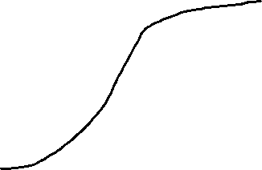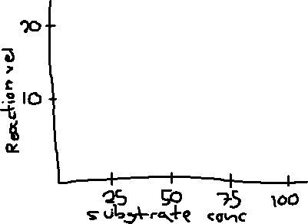

Since $V_{max}=20 mM/s$, we must make sure that the plot of the graph does not go above $20 mM/s$ but approaches it. $h=4$ will have a steep curve with an initial flat range but not as intense as a graph with $h=10$. The $k_{1/2}=50$ dictates that we will reach half of the maximum reaction velocity, $10 mM/s$ at $50 mM$ substrate concentration. To check our work we can plot the graph in MATLAB to get the same results as above:

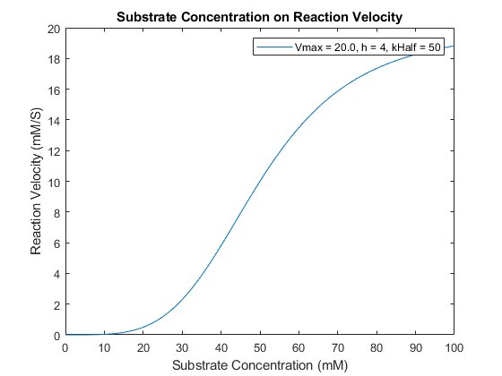

**PartA2b** plot of the hill equation with $h=4, k_{1/2}=50 mM$, and $V_{max}=20 mM/s$

In terms of real-life applications, we can model the dynamics of an enzyme catalyzed reaction using the hill equation. For example, $E+S→E+P$ and we want to know what the concentration of $S$ is. However, we should note that the hill equation models the reaction velocity at different substrate concentrations and not the actual concentration itself. What this means is that we know how fast the reaction will proceed given a certain concentration, therefore we’ll need to use another method to simulate how the reaction will proceed, the Forward Euler Method. This method takes an initial value and calculates the change in the value over time by taking the rate of change at that point in time, multiplying it by a small value, and then adding it to the initial value. The hill equation is already a “derivative” so to model how $S$ will change over time only requires us to negate the derivative due to the substrate being used up in the reaction:

$$\frac{d\left[S\right]}{dt}=-v=\frac{-V_{max}{\left[S\right]}^{h}}{K_{1/2}^{h}+{\left[S\right]}^{h}}$$

We can get relatively accurate results with this method. Using this method to simulate the change in substrate concentration with $h =4$, $V_{max}=20 mM/s$, $k_{1/2}=50$, we get this graph:

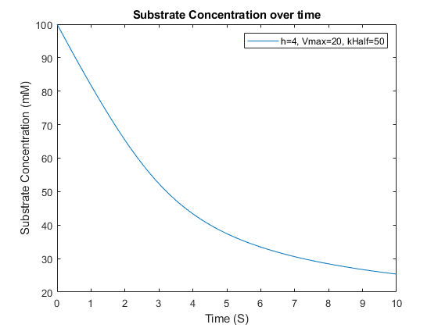

**PartA3b** the graph of the substrate concentration over time with $h=4$, $V_{max}=20 mM/s$, and $K_{1/2}=50$

A keen eye will notice that this graph does not look like the graphs previously discussed. This is because this graphs the change in the substrate concentration over time as opposed to the substrate velocity for a given substrate concentration. For example, at $\left[S\right]=100 mM$, the calculated reaction velocity is somewhere near $19 mM/s$. The period of time from $0 s$ to $1 s$ shows a decrease in substrate concentration of $19 mM$. Toward the end where the substrate concentration is near the mid-twenties, the calculated reaction velocity is also low, explaining why the substrate concentration flattens as we approach the $10 s$ mark.

**Part B: An Autoregulatory Gene**

An auto regulatory gene is a gene that codes for a protein whose function is to regulate the activity of the gene itself. The system of equations for such a gene is:

$$\frac{d\left[χ_{rna}\right]}{dt}=\frac{μ{\left[χ_{prot}\right]}^{2}}{K_{\frac{1}{2}}^{2}+{\left[χ_{prot}\right]}^{2}}-χ_{rna}\left[χ_{rna}\right]$$

$$\frac{d\left[χ_{prot}\right]}{dt}=ω\left[χ_{rna}\right]-χ_{prot}[χ_{prot}]$$

$[χ_{rna}]$ and $[χ_{prot}]$ is the concentration of RNA and protein, respectively, $μ$ is the maximum reaction velocity for proteins acting on RNA. $K_{1/2}$ is the protein concentration requiring for the protein to reach half of its maximum reaction velocity. $χ_{rna}$ is a coefficient that impacts the effect the concentration of RNA on the rate of change in the RNA concentration. $ω$ is the coefficient that impacts the effect the concentration of RNA on the rate of change in protein concentration. $χ_{prot}$ is the coefficient that impacts the effect the concentration of protein has on the rate of change in protein concentration. The term $\frac{μ{\left[χ_{prot}\right]}^{2}}{K_{1/2}^{2}+{\left[χ_{prot}\right]}^{2}}$ is a growth term that increases that concentration of RNA based on the hill equation discussed previously. $-χ_{rna}[χ_{rna}]$ is the decaying term based on the RNA concentration. $ω[χ_{rna}]$ is the growth term based on the RNA concentration. $-χ_{prot}[χ_{prot}]$ is the decaying term based on the protein concentration.

Using the parameters $μ=ω=χ_{prot}=χ_{rna}=1s^{-1}$ and $K_{\frac{1}{2}}=0.33$, we’ll explore how the system reacts to different initial starting concentrations of RNA and proteins.

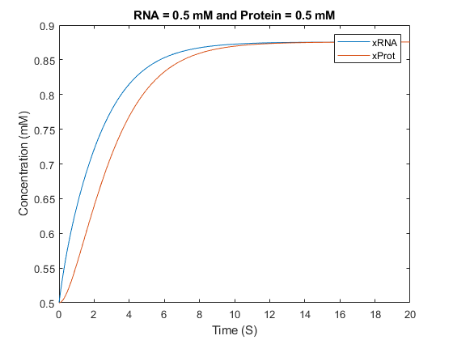

**PartB1a** concentration plots for the RNA and protein with the same starting conditions. Notice how the two converges to a single concentration value.

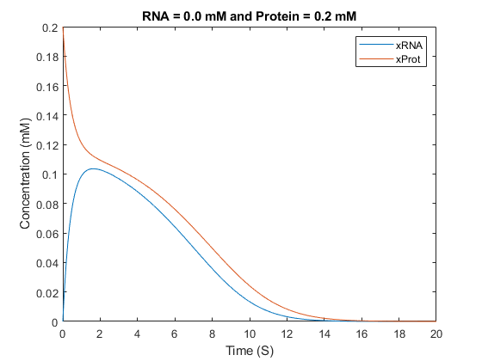

**PartB1b** concentration plots for RNA and proteins with different starting conditions. Initial protein concentration is 0.2 and initial RNA concentration is 0. Since protein concentration is directly tied to RNA concentration, having no initial RNA means that the protein concentration will rapidly drop.

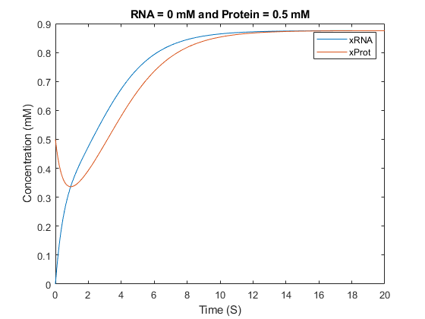

**PartB1c** concentration plots for RNA and protein with starting conditions of $0 mM$ and $0.5 mM$, respectively. Although there were no initial concentrations of RNA, the concentration of proteins were high enough to generate a high enough reaction velocity for the RNA to increase in concentration enough that a feedback loop was generated.

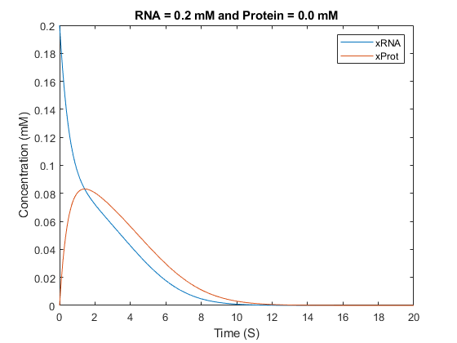

**PartB1d** concentration plots for RNA and protein with starting conditions of $0.2 mM$ and $0.0 mM$, respectively. Like the graph whose starting conditions were $\left[RNA\right]=0.0 mM$ and $\left[Protein\right]=0.2 mM$, the RNA was able to cause some protein to be created, however the protein concentration was insufficient to allow the gene to create more RNA and sustain a feedback loop.

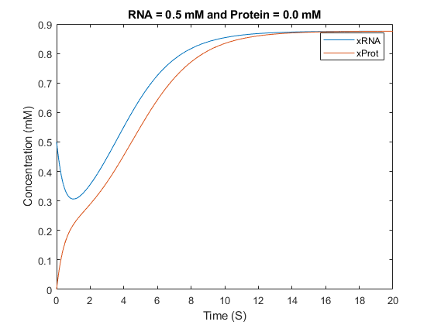

**PartB1e** Concentration plots for RNA and protein with starting conditions of $0.5 mM$ and $0.0 mM$, respectively. However, this time the concentration of protein is sufficient for rate of change for the RNA to go positive and introduce a feedback loop.

This system shows that RNA is dependent on protein concentration and protein is dependent on RNA concentration; one cannot exist without the other. And the starting conditions of the RNA and protein is vital to determine if there is a feedback mechanism where both other them will increase the concentration of each other or both will cause a decreases in concentration due to both not being in a sufficient concentration.

Exploring the how the system will react to different initial values of proteins and RNA is time consuming. What we want to know is how the system will react to different concentrations for a variety of starting conditions. We can modify the MATLAB code to model 64 different plots and generate a graph like this:

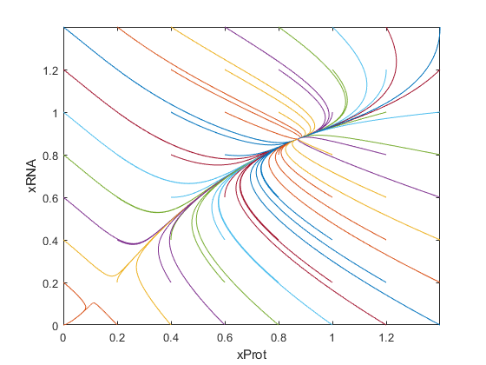

**PartB2a** The plot of 64 lines showing their trajectories. Note that the change in concentration for both protein and RNA is not dependent on time, rather they are dependent on concentration only. That means that for a graph which happens to have the same value as the initial value for another graph, their trajectories will be nearly identical. This can be seen in the top left of the graph where some lines are obscured by another line.

Each of the lines begin at an initial protein concentration and RNA concentration between 0 – 1.4 at increments of 0.2. Each point on the graph has a change in protein concentration and change in RNA concentration related to it. An interesting thing to note is how most of the plots converge to a point around $(0.9, 0.9)$ save for 3 plots that converge to $(0, 0)$. These two points are stable stationary points that all trajectories gravitate towards depending on the parameters that we set for the system. A system with different parameters will have stationary points at different places.

The system above can give us an insight on how such a system will function. If we start with a low quantity of RNA and protein, we’ll eventually end up with no protein and RNA. In a biological sense, this could represent a system where the concentration of either substance is insufficient for a positive feedback loop to take place, leading to a deactivated gene. If we started with a higher quantity instead of RNA and protein, we’ll converge to a point where the gene is constitutively active.

**Appendix**

**PartA1a**

Vmax = 5.0;

h1 = 1;

h2 = 2;

h3 = 10;

kHalf = 20.0;

S = 0:0.05:100;

for i = 1:length(S)

V1(i) = (Vmax * power(S(i), h1)) / (power(kHalf, h1) + power(S(i), h1));

V2(i) = (Vmax * power(S(i), h2)) / (power(kHalf, h2) + power(S(i), h2));

V3(i) = (Vmax * power(S(i), h3)) / (power(kHalf, h3) + power(S(i), h3));

end

plot(S, V1, "DisplayName", "h = 1");

hold on

plot(S, V2, "DisplayName", "h = 2");

plot(S, V3, "DisplayName", "h = 10");

legend

title("Impact of h on Substrate Concentration over Time");

xlabel("Substrate Concentration (mM)");

ylabel("Reaction Velocity (mM/S)");

hold off

**PartA1b**

Vmax = 5.0;

h = 2;

kHalf1 = 10.0;

kHalf2 = 20.0;

kHalf3 = 40.0;

S = 0:0.05:100;

for i = 1:length(S)

V1(i) = (Vmax * power(S(i), h)) / (power(kHalf1, h) + power(S(i), h));

V2(i) = (Vmax * power(S(i), h)) / (power(kHalf2, h) + power(S(i), h));

V3(i) = (Vmax * power(S(i), h)) / (power(kHalf3, h) + power(S(i), h));

end

plot(S, V1, "DisplayName", "kHalf1 = 10.0");

hold on

plot(S, V2, "DisplayName", "kHalf2 = 20.0");

plot(S, V3, "DisplayName", "kHalf3 = 40.0");

legend

title("Impact of kHalf on Substrate Concentration over Time")

xlabel("Substrate Concentration (mM)");

ylabel("Reaction Velocity (mM/S)");

hold off

**PartA1c**

Vmax1 = 2.0;

Vmax2 = 5.0;

Vmax3 = 10.0;

h = 2;

kHalf = 20;

S = 0:0.05:100;

for i = 1:length(S)

V1(i) = (Vmax1 * power(S(i), h)) / (power(kHalf, h) + power(S(i), h));

V2(i) = (Vmax2 * power(S(i), h)) / (power(kHalf, h) + power(S(i), h));

V3(i) = (Vmax3 * power(S(i), h)) / (power(kHalf, h) + power(S(i), h));

end

plot(S, V1, "DisplayName", "Vmax1 = 2.0");

hold on

plot(S, V2, "DisplayName", "Vmax2 = 5.0");

plot(S, V3, "DisplayName", "Vmax3 = 10.0");

legend

title("Impact of Vmax on Substrate Concentration over Time");

xlabel("Substrate Concentration (mM)");

ylabel("Reaction Velocity (mM/S)");

hold off

**PartA2b**

Vmax = 20.0;

h = 4;

kHalf = 50;

S = 0:0.05:100;

for i = 1:length(S)

V1(i) = (Vmax * power(S(i), h)) / (power(kHalf, h) + power(S(i), h));

end

plot(S, V1, "DisplayName", "Vmax = 20.0, h = 4, kHalf = 50");

hold on

legend

title("Substrate Concentration on Reaction Velocity");

xlabel("Substrate Concentration (mM)");

ylabel("Reaction Velocity (mM/S)");

hold off

**PartA3a**

clear

Vmax = 20;

kHalf = 50;

h = 4;

dt = 0.01;

Time = 0:dt:10;

S(1) = 100;

for i = 1:(length(Time) - 1)

dSdt(i) = -((Vmax * power(S(i), h))/(power(kHalf, h) + power(S(i), h)));

S(i + 1) = S(i) + dSdt(i) * dt;

end

plot(Time, S, DisplayName="h=4, Vmax=20, kHalf=50");

hold on

legend

xlabel("Time (S)");

ylabel("Substrate Concentration (mM)");

title("Substrate Concentration over time");

hold off

**PartB1a**

clear

u = 1;

w = 1;

xprot = 1;

xrna = 1;

kHalf = 0.33;

h = 2;

dt = 0.01;

Time = 0:dt:20;

xProt(1) = 0.5;

xRNA(1) = 0.5;

for i = 1:length(Time) - 1

dXrnaDt(i) = (u * power(xProt(i), 2)) / (power(kHalf, 2) + power(xProt(i), 2)) - (xrna * xRNA(i));

dXproDt(i) = w * xRNA(i) - xprot * xProt(i);

xRNA(i + 1) = xRNA(i) + dXrnaDt(i) * dt;

xProt(i + 1) = xProt(i) + dXproDt(i) * dt;

end

plot(Time, xRNA, DisplayName="xRNA");

hold on

plot(Time, xProt, DisplayName="xProt");

legend

title("RNA = 0.5 mM and Protein = 0.5 mM");

xlabel("Time (S)");

ylabel("Concentration (mM)");

hold off

**PartB1b**clear

u = 1;

w = 1;

xprot = 1;

xrna = 1;

kHalf = 0.33;

h = 2;

dt = 0.01;

Time = 0:dt:20;

xProt(1) = 0.2;

xRNA(1) = 0;

for i = 1:length(Time) - 1

dXrnaDt(i) = (u * power(xProt(i), 2)) / (power(kHalf, 2) + power(xProt(i), 2)) - (xrna * xRNA(i));

dXproDt(i) = w * xRNA(i) - xprot * xProt(i);

xRNA(i + 1) = xRNA(i) + dXrnaDt(i) * dt;

xProt(i + 1) = xProt(i) + dXproDt(i) * dt;

end

plot(Time, xRNA, DisplayName="xRNA");

hold on

plot(Time, xProt, DisplayName="xProt");

legend

title("RNA = 0.0 mM and Protein = 0.2 mM")

xlabel("Time (S)");

ylabel("Concentration (mM)");

hold off

**PartB1c**clear

u = 1;

w = 1;

xprot = 1;

xrna = 1;

kHalf = 0.33;

h = 2;

dt = 0.01;

Time = 0:dt:20;

xProt(1) = 0.5;

xRNA(1) = 0;

for i = 1:length(Time) - 1

dXrnaDt(i) = (u * power(xProt(i), 2)) / (power(kHalf, 2) + power(xProt(i), 2)) - (xrna * xRNA(i));

dXproDt(i) = w * xRNA(i) - xprot * xProt(i);

xRNA(i + 1) = xRNA(i) + dXrnaDt(i) * dt;

xProt(i + 1) = xProt(i) + dXproDt(i) * dt;

end

plot(Time, xRNA, DisplayName="xRNA");

hold on

plot(Time, xProt, DisplayName="xProt");

legend

title("RNA = 0.0 mM and Protein = 0.5 mM");

xlabel("Time (S)");

ylabel("Concentration (mM)");

hold off

**PartB1d**clear

u = 1;

w = 1;

xprot = 1;

xrna = 1;

kHalf = 0.33;

h = 2;

dt = 0.01;

Time = 0:dt:20;

xProt(1) = 0;

xRNA(1) = 0.2;

for i = 1:length(Time) - 1

dXrnaDt(i) = (u * power(xProt(i), 2)) / (power(kHalf, 2) + power(xProt(i), 2)) - (xrna * xRNA(i));

dXproDt(i) = w * xRNA(i) - xprot * xProt(i);

xRNA(i + 1) = xRNA(i) + dXrnaDt(i) * dt;

xProt(i + 1) = xProt(i) + dXproDt(i) * dt;

end

plot(Time, xRNA, DisplayName="xRNA");

hold on

plot(Time, xProt, DisplayName="xProt");

legend

title("RNA = 0.2 mM and Protein = 0.0 mM")

xlabel("Time (S)");

ylabel("Concentration (mM)");

hold off

**PartB1e**clear

u = 1;

w = 1;

xprot = 1;

xrna = 1;

kHalf = 0.33;

h = 2;

dt = 0.01;

Time = 0:dt:20;

xProt(1) = 0;

xRNA(1) = 0.5;

for i = 1:length(Time) - 1

dXrnaDt(i) = (u * power(xProt(i), 2)) / (power(kHalf, 2) + power(xProt(i), 2)) - (xrna * xRNA(i));

dXproDt(i) = w * xRNA(i) - xprot * xProt(i);

xRNA(i + 1) = xRNA(i) + dXrnaDt(i) * dt;

xProt(i + 1) = xProt(i) + dXproDt(i) * dt;

end

plot(Time, xRNA, DisplayName="xRNA");

hold on

plot(Time, xProt, DisplayName="xProt");

legend

title("RNA = 0.5 mM and Protein = 0.0 mM");

xlabel("Time (S)");

ylabel("Concentration (mM)");

hold off

**PartB2a**clear

u = 1;

w = 1;

xprot = 1;

xrna = 1;

kHalf = 0.33;

h = 2;

dt = 0.01;

Time = 0:dt:20;

for x = 0:0.2:1.4

for y = 0:0.2:1.4

xProt(1) = x;

xRNA(1) = y;

for i = 1:length(Time) - 1

dXrnaDt(i) = (u * power(xProt(i), 2)) / (power(kHalf, 2) + power(xProt(i), 2)) - (xrna * xRNA(i));

dXproDt(i) = w * xRNA(i) - xprot * xProt(i);

xRNA(i + 1) = xRNA(i) + dXrnaDt(i) * dt;

xProt(i + 1) = xProt(i) + dXproDt(i) * dt;

end

plot(xProt, xRNA);

hold on

end

end

xlabel("xProt");

ylabel("xRNA");

hold off